Roll:2007109
Thesis Title: Vehicle-Aware Dynamic Path Planning in Dhaka Using an Improved Ant Colony Algorithm with a Pool-Based Framework for Disruption-Resilient Routing
Alternate Titles:
1. Vehicle-Aware Dynamic Path Planning for Disruption-Resilient Routing in Dhaka Using an Improved Ant Colony Algorithm.
2. Disruption-Resilient Dynamic Routing in Dhaka: An Improved Ant Colony Optimization Approach with Vehicle-Aware Path Pools.
3. A Pool-Based Alternative Path Planning Framework for Dynamic and Vehicle-Aware Routing in Congested Dhaka
4. Improved Ant Colony-Based Dynamic Path Planning with Vehicle-Aware Alternative Routing for Congested Roads in Dhaka

1. General Objective: To develop a vehicle-aware, pool-based dynamic routing framework for Dhaka that can provide feasible alternative paths quickly during sudden road disruptions.

2. Specific Objectives:
1. To develop a vehicle-aware road classification and access framework for Dhaka.
2. To generate feasible and ranked alternative routes for each source–destination pair and vehicle category.
3. To model disruption events and identify affected trips for dynamic rerouting.
4. To evaluate whether pool-based rerouting performs better than other rerouting strategies in terms of efficiency and network stability.

3. Research Questions:
RQ1: How can vehicles in Dhaka be rerouted quickly when a road is suddenly blocked or a link is broken?
RQ2: How can route planning be made vehicle-aware, so that different vehicle types use only roads that are feasible for them?
RQ3: How can a steady-state set of feasible alternative routes be prepared in advance for each source-destination pair and each vehicle category?
RQ4: Can disruption risk or fragility of sensitive corridors be considered during pool construction to make alternative routing more reliable?
RQ5: How should rerouting be performed after disruption: from the original source, from the current
vehicle position, or from a precomputed path pool?

4. Research Framework:
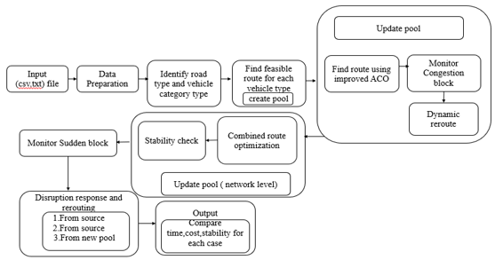
Figure: Proposed Vehicle-Aware, Pool-Based Routing Framework
The proposed framework begins with input data such as road network information, source,destination pairs, and vehicle access rules, after which roads are classified and vehicles are categorized according to their suitability for different road types. Feasible routes are then generated for each vehicle category under normal steady-state conditions, and a pool of alternative paths is prepared in advance using an improved Ant Colony Optimization method. The framework next considers network-level interactions and checks overall stability. When a sudden road blockage occurs, it identifies the affected routes and applies three rerouting strategies: rerouting from the source, rerouting from the current position, and rerouting using the precomputed path pool. Finally, the performance of these strategies is compared in terms of time, cost, and network stability to identify the most efficient rerouting approach.
5. Significance of the Proposed Method:
1.The proposed method is more realistic than conventional shortest-path or congestion-only methods because it incorporates vehicle category, road width, road hierarchy, and access feasibility.
2.It introduces a precomputed, ranked, vehicle-aware pool of alternative paths, instead of relying only on single-route recomputation after disruption.
3.It provides a disruption-resilient framework by comparing three rerouting strategies and evaluating recovery in terms of time, iterations, computational effort, and final path cost.

References:
[1] M. A. H. Akhand, M. A. Habib, M. A. S. Kamal, and N. Siddique, “Physarum-Inspired Bicycle Lane Network Design in a Congested Megacity,” Applied Sciences, vol. 11, no. 15, Art. no. 6958, 2021, doi: 10.3390/app11156958.
[2] C. Wu, S. Zhou, and L. Xiao, “Dynamic Path Planning Based on Improved Ant Colony Algorithm in Traffic Congestion,” IEEE Access, vol. 8, pp. 180773–180783, 2020, doi: 10.1109/ACCESS.2020.3028467.
[3] R. Bader, J. Dees, R. Geisberger, and P. Sanders, “Alternative Route Graphs in Road Networks,” in Theory and Practice of Algorithms in (Computer) Systems, A. Marchetti-Spaccamela and M. Segal, Eds. Berlin, Heidelberg: Springer Berlin Heidelberg, 2011, pp. 21–32.

Plan to Complete the Thesis Work and Publication (If):
Step 1: The framework is expected to be publishable, with most methodology implemented by April.
Step 2: The remaining work and thesis report are expected to be completed by 25 June prior to the defense.
Step 3: The publication manuscript is expected to be prepared and submission-ready by July.

